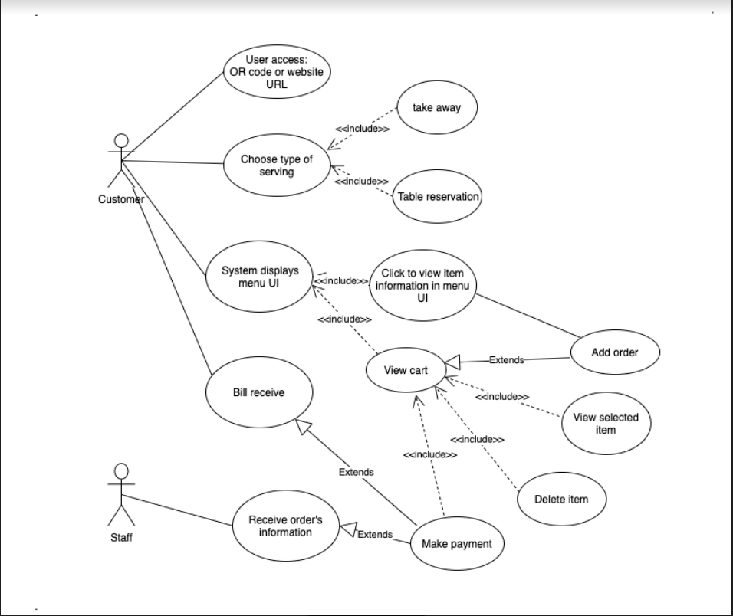

| Use-case name | Food ordering |
| --- | --- |
| Actor | Customer, Clerk |
| Description | Customer chooses and orders items |
| Preconditions | Website is available, Internet is available, Database is loaded |
| Normal Flow | 1. Access Web page 2. Customer views menu 3. Customer choose type of serving (take away, table serving or shipping to home) 4. Customer select a item and view item’s details 5. If they want this item, make an order (choose quantity, size, options) 6. The item is added to cart 7. Continue to select other items (repeat from step 2). 8. After select all the items you want, view the cart’s information 9. Customer can edit or delete the items they don’t want anymore 10. Make a payment 11. Clerk receive order’s information |